Maman Saly Mbengue

**Project report**

**Description:**

This project simulates an e-commerce shopping cart system using object-oriented programming (OOP) concepts. The system consists of different types of products, including digital and physical products, and allows users to manage their shopping carts by adding/removing items, applying discounts, and performing checkout operations. The project also includes functionalities for applying different discount types (percentage-based and fixed amount discounts) and managing user operations seamlessly.The system implements various OOP concepts, such as inheritance, polymorphism, encapsulation, and abstraction, providing a structured and modular approach to handling product details and user interactions in a shopping cart.

**Instructions:**

To use the shopping cart system, first create instances of `DigitalProduct` and `PhysicalProduct` with the required attributes. For digital products, you need to specify details like `file_size` and `download_link`, while for physical products, you must provide attributes such as `weight`, `dimensions`, and `shipping_cost`. Next, create instances of the `User` class, each representing a user with their own shopping cart. Products can be added to a user's cart using the `add_to_cart()` method, and the cart can be viewed using the `view_cart()` method. Users can apply discounts by creating instances of either the `PercentageDiscount` or `FixedAmountDiscount` classes and passing them to the `checkout()` method. The checkout process will calculate the total price, apply the specified discount, and clear the cart after the transaction is completed. Throughout the process, the system ensures that all cart operations are managed through user-friendly methods that hide the underlying complexity. This setup allows users to easily manage their shopping experience, apply discounts, and finalize their purchases.

**Structure:**

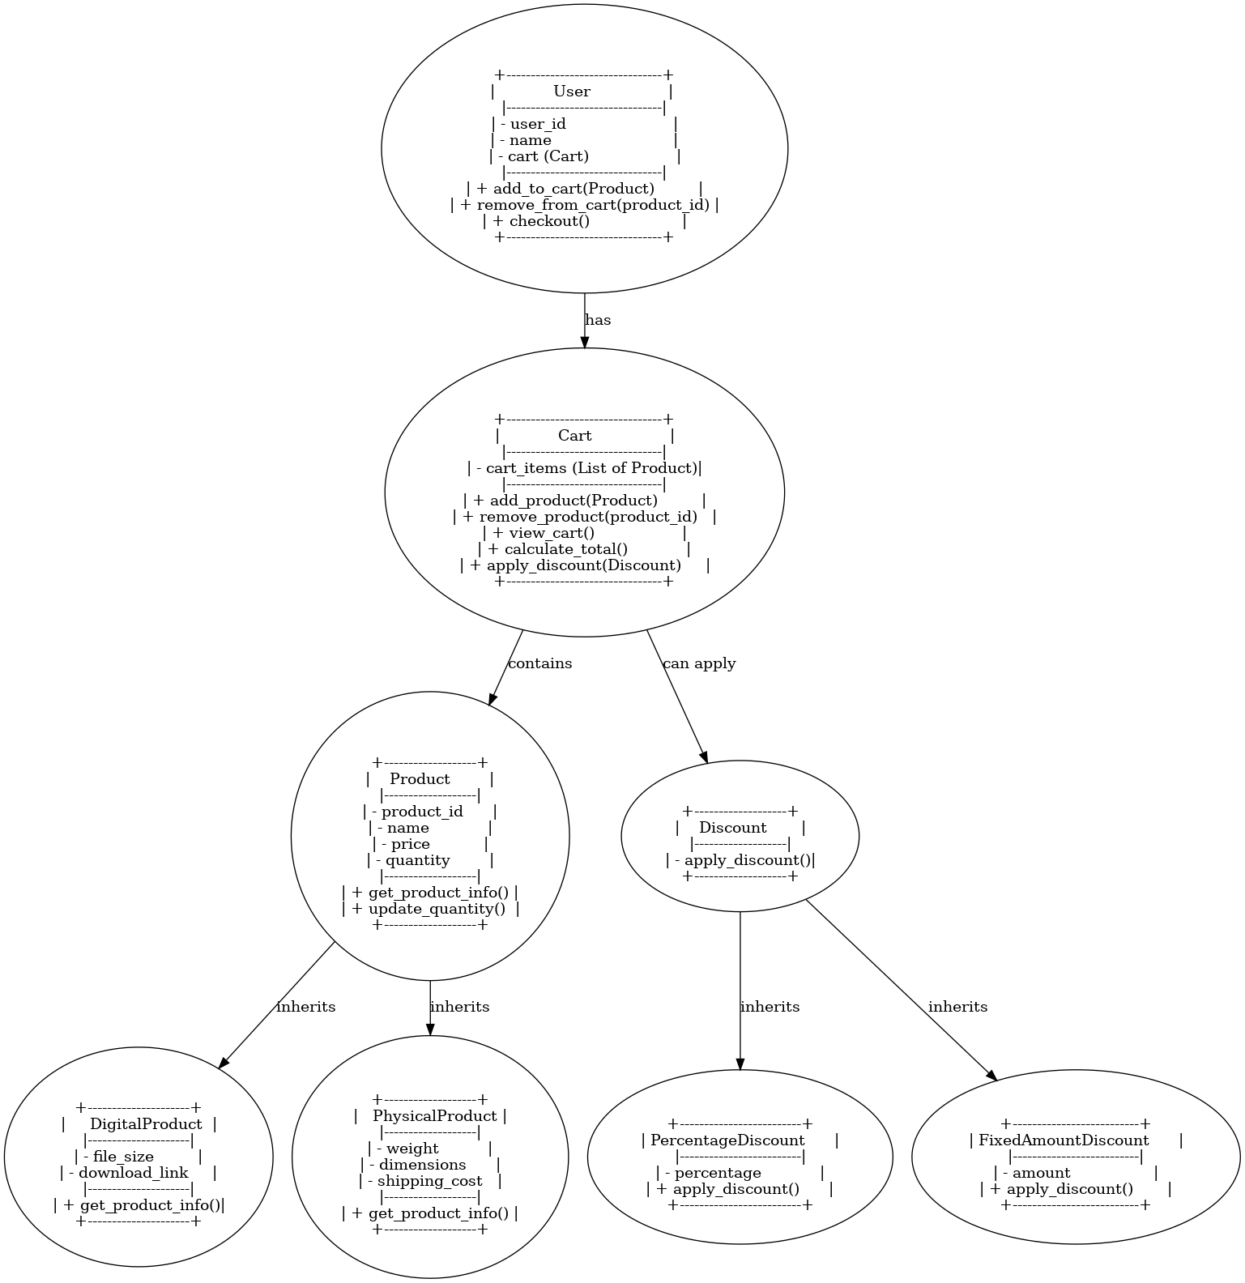

### **Brief Summary on Developed Classes**

* **Product Class**: Represents a product with attributes such as product_id, name, price, and quantity. It includes methods like update_quantity() to modify stock and get_product_info() to retrieve details about the product.
* **DigitalProduct Class**: Inherits from Product, adding file_size and download_link attributes to handle digital items. It overrides get_product_info() to display digital-specific details.
* **PhysicalProduct Class**: Also inherits from Product, introducing additional attributes like weight, dimensions, and shipping_cost to handle physical goods. It overrides get_product_info() to include shipping-related information.
* **Cart Class**: Manages a collection of products in a private list called cart_items. It includes methods such as add_product(), remove_product(), view_cart(), calculate_total(), and apply_discount() to facilitate cart management and discount application.
* **User Class**: Represents a user with a user_id, name, and a cart. It provides methods like add_to_cart(), remove_from_cart(), and checkout() to interact with the shopping process.
* **Discount Class (Abstract)**: Serves as a base class for discount strategies, defining an abstract method apply_discount().
* **PercentageDiscount Class**: Implements apply_discount() to apply a percentage-based discount on the cart total.
* **FixedAmountDiscount Class**: Implements apply_discount() to reduce the total price by a fixed amount.

**Verification of sanity of code:**

#### **Scenario 1: Adding Products to User Carts**

**Use the add_to_cart method under the User class. This method takes one argument: the product that the user wants to add to their cart. In the following case, I create two users and add digital products to User 1’s cart and physical products to User 2’s cart.**

**Before Adding Products:  
 User 1’s cart is empty.  
 User 2’s cart is empty.**

**After Adding Products:**

**User 1’s cart contains 2 digital products.**

**User 2’s cart contains 3 physical products.**

**Code Execution:**

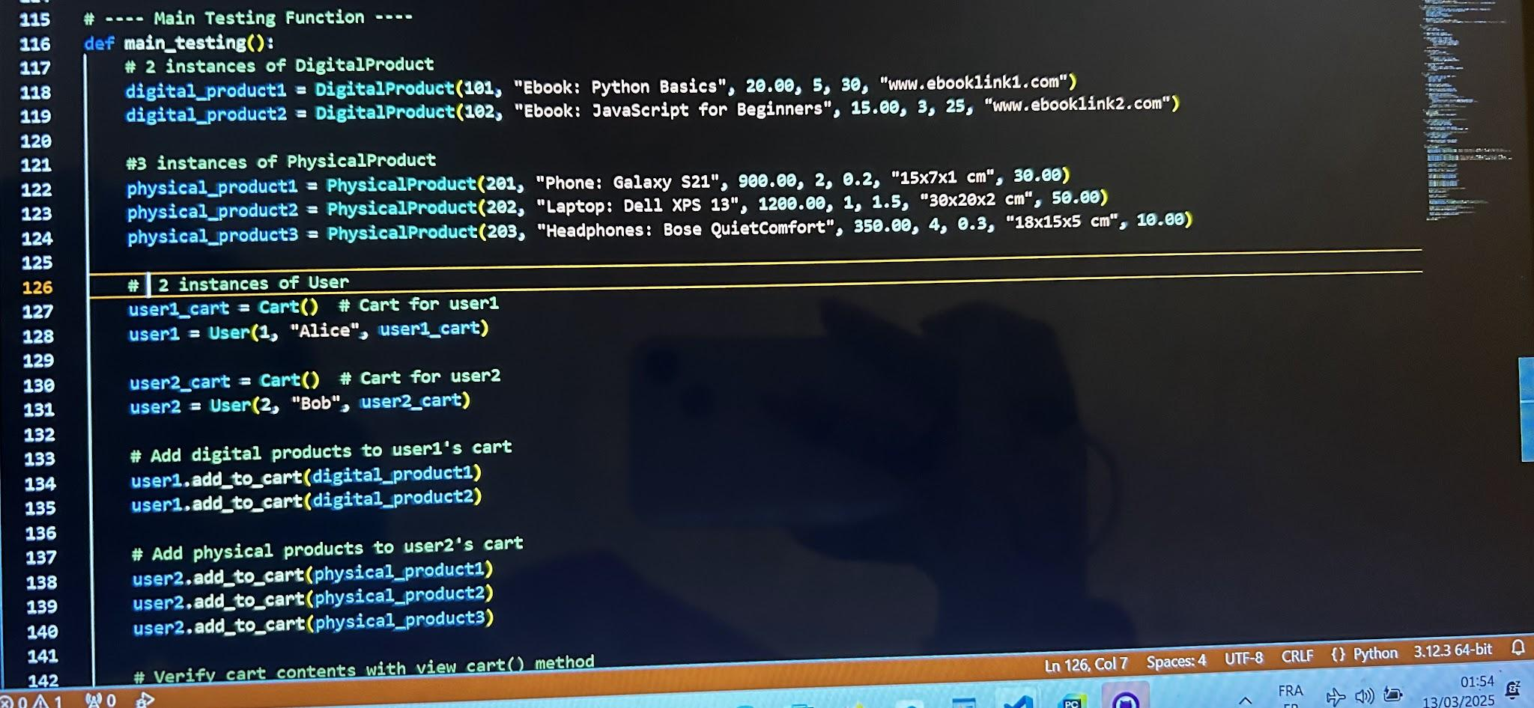

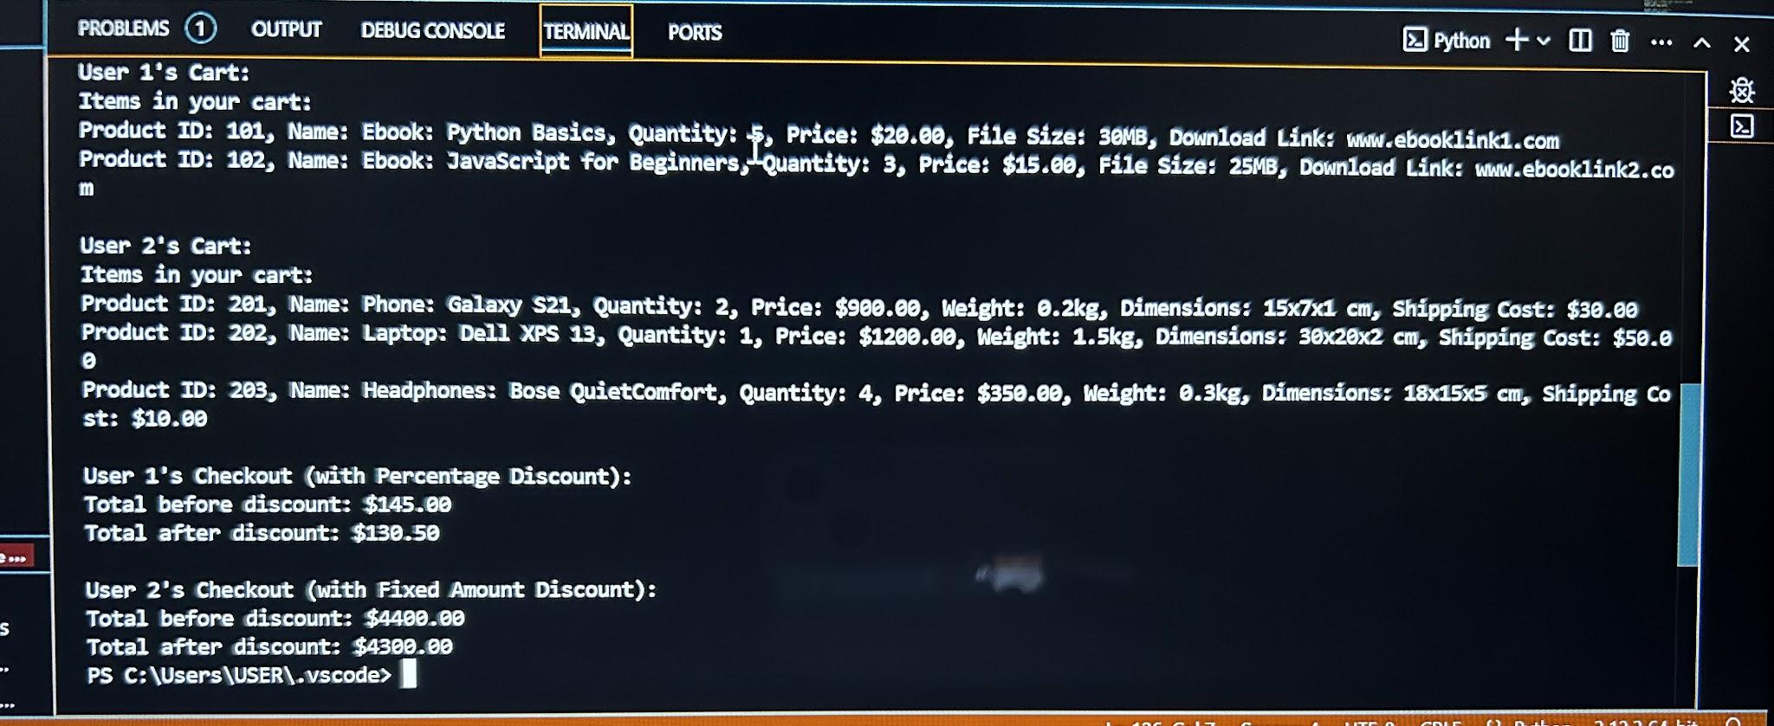

#### **Scenario 2: Viewing Cart Contents**

**Use the** view_cart **method under the Cart class. This method prints out the details of all products in a user’s cart.**

**Code Execution:**

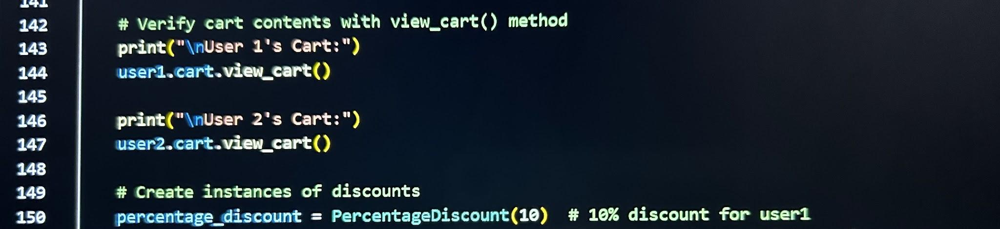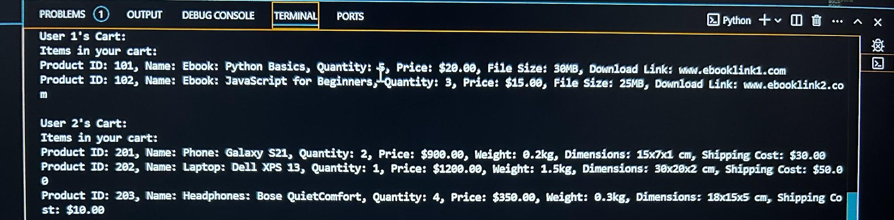

#### **Scenario 3: Applying Discounts and Checking Out**

**Use the checkout method under the User class. This method calculates the total cart value and applies discounts before clearing the cart.**

**Code Execution:**

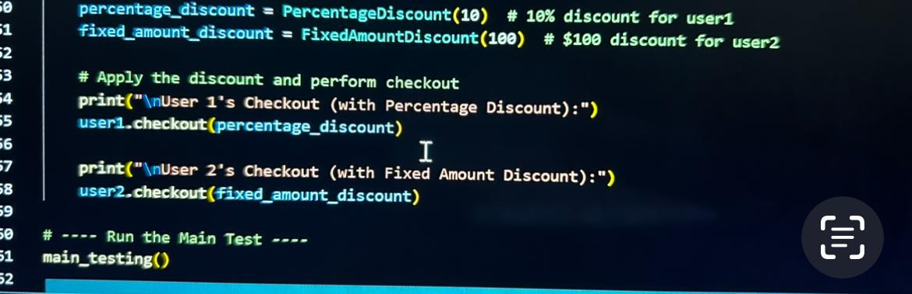

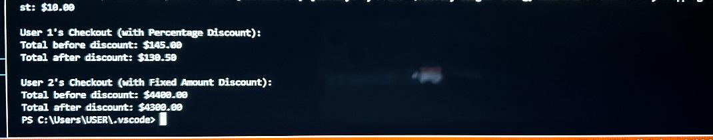

**Conclusion:**

Working on this project came with a few challenges, but it was a great learning experience. One of the biggest difficulties was making sure all the classes worked well together while keeping the code organized and easy to understand. Figuring out how to connect the User, Cart, and Product classes took some time, especially when making sure products could be added and removed properly. Another tricky part was applying discounts in a way that was flexible but still simple to use. Creating an abstract Discount class and having PercentageDiscount and FixedAmountDiscount inherit from it helped make the code more reusable. Keeping track of product quantities was another challenge, as we had to make sure users couldn’t buy more than what was available. Despite these challenges, using object-oriented programming made the project much easier to manage. Breaking everything into separate classes helped keep the code clean and organized. However, there are some areas that could be improved. For example, adding a way to save user carts and product inventory so they don’t reset every time the program runs would make the system more useful. It would also be interesting to add more types of discounts or special deals. Overall, this project was a great way to practice using classes and objects in Python, and it really showed how important good code structure is in making a program easy to use and expand in the future.